**<http://www.acsu.buffalo.edu/~mychalos/>**

Muzna Ahmed

Collin Ellis

Mychal Ostuni

Jonathan Skowron

Zakkiyah Wilbert

We have created a database with the purpose of tracking the development of students at Alexander Hamilton Elementary School. To give a brief background of how the school is set up, students are placed in grade levels kindergarten through fifth grade, based primarily on age. Each grade level consists of three classrooms (with one teacher assigned to each classroom), which consists of approximately 20 students.

This database tracks student assessment scores throughout these six years in one single file. The existing system at Hamilton consists of excel files, which are created for each school year. They contain student data which is transferred three times per school year (beginning, middle, and end) to word documents for classroom reports, once data collection and entry is complete. The current process takes two to three weeks. Our database would cut this time in half.

The proposed database system expedites and simplifies the process of generating reports by keeping the data in one single, growing file, making the process of inputting data and generating reports much more efficient. Invaluable time spent creating and maintaining folders of data is eliminated by our Access database. This will allow teacher aides to spend their time providing students with the help that they need. There is an immeasurable amount of value in this opportunity.

Our Access database consists of five tables: “student”, “school year”, “grade”, “test period”, and “tests”.  The “student” table consists of the students’ name and date of birth, with a student ID as their primary key.  The “grade” table simply consists of the grade levels (primary key) and their given name.  Students are linked to a grade level through an intersection table titled “school year”.  It is here that student ID’s (foreign key) are linked with information telling us which room # and teacher, they have been assigned to in any given year, at a particular grade level (foreign key).

The “tests” table consists of fields containing the test name [at this point we only have tests called DIBELS and Fountas & Pinell (F&P)], subject (at this point we only have reading tests), which period the test is being given in (1 – beginning, 2 – middle, or 3 – end), and the benchmark is for a test in a given period.  The tests table will be linked to the students and all of their information (at a particular point in time) through an intersection table called “test period”.  “Test period” will contain the test scores. Here, test scores will be linked to the particular tests given at a specific point in time, to the students and all of their information at a specific point in time.

A collection of queries has been created in order to create useful forms and reports. An individual student, entire class, or entire grade level may be queried for data entry or the creation of reports. A menu system has been created for organization and parameters have been set up to facilitate processes.

We were able to create a great amount of data, but due to the nature of student records flowing through time, it is likely that a query may pull up a classroom or an entire grade level that does not have a single record, despite creating over 100 student records and well over 1000 test scores. For this purpose, here is a table that shows exactly how many records will be returned given queries of any of the following classrooms/grade levels and years:

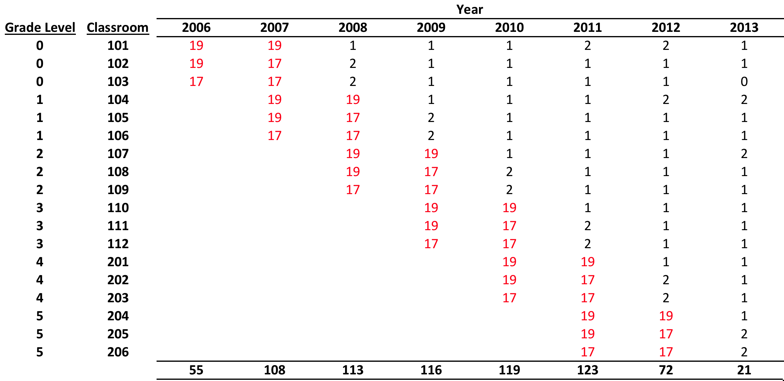

In addition to entering a year and classroom/grade level, you will also be required to enter which period you would like to query. You will enter ‘1’, ‘2’ or ‘3’ for beginning, middle or end, respectively.

DIBELS and F&P assessments each have forms that have the ability to pull a desired student, class or grade level for the purpose of entering or editing data. It is common to collect data in batches of test scores, which makes the ability to query a classroom or entire grade level very valuable. In reality, data collection by batch is often interrupted by lunch, fire drill, absence, etc. In this case, when we only have a very small amount of scores to input, we may only need to use a ‘student’ form, which will pull up a single student by their student ID number (‘1’ through ‘129’).

The current system is set up to create six different reports: student, classroom and grade level for DIBELS, and the same for F&P. Queries were customized to produce each report. Following is a description of each report and the value that each one provides:

**For all DIBELS reports** – scores of 1, 2, or 3 were inputted, which by means of an IIF statement, yield “instructional recommendations” of ‘intensive’, ‘strategic’ or ‘benchmark’, respectively. Conditional formatting has been set up so that any score yielding an instructional recommendation of intensive is red, strategic is orange, and benchmark is green. The purpose of this is to convey the severity of the recommendation to the report reader.

**Student report** – an individual student’s history of instructional recommendations throughout their time at the school, in chronological order to show patterns of improvement or regression.

**Classroom report** – an individual classroom, in an individual year, for an individual testing period. Students are grouped by their instructional recommendation, which are sorted by severity, allowing teachers to make decisions about their classrooms.

**Grade level report** – an individual grade level, in an individual year, for an individual testing period. Students are grouped by their instructional recommendation, which are sorted by severity. Within each instructional recommendation, students are also sorted by class. This allows administration and reading specialists to identify patterns at the scope of an entire grade level.

**All F&P reports** – scores ranging from 1 to 26 were inputted, which represent letters A to Z, respectively. An IIF statement was attempted to be set up so the numbers would yield corresponding letters, but apparently it was a bit too in depth for Access’ liking. A score of 1 (or A) represents the most basic reading level and conversely, a score of 26 (or Z) represents the most advanced reading level. Conditional formatting has been set up so that any score that is below its corresponding testing period’s benchmark will be turned red. The purpose of this is to highlight the severity of a “below benchmark” score.

**Student report** – an individual student’s history of reading levels throughout their time at the school, in chronological order to show patterns of improvement or regression.

**Classroom report** – an individual classroom, in an individual year, for an individual testing period. Students are sorted by their reading level in ascending order, which brings lowest reading levels to the top of the report.

**Grade level report** – an individual grade level, in an individual year, for an individual testing period. Students are sorted by their reading level in ascending order, which brings lowest reading levels to the top of the report.

This allows administration and reading specialists to identify patterns at the scope of an entire grade level.

**Future Enhancements –**

1. To show reading levels of A through Z rather than numbered scores.

2. To be able to include scores of multiple testing periods in columns, next to one another within reports. We spent a great amount of time trying to accomplish this before moving on.

3. To include more tests in our system.

**Backup/Maintenance Strategy –**

The database will be stored on the districts S drive as well as continually saved on a solid state drive in the principal’s office. This will give us two back up mechanisms that are very reliable.

